21BDS0340

Abhinav Dinesh Srivatsa

Exploratory Data Analysis Lab

**Experiment 10**

**Code:**

# loading libraries and data

library(cluster)

data = iris

**Output:**

> # loading libraries and data

> library(cluster)

> data = iris

**Code:**

# calculating euclidean distance

euclidean = daisy(data[0:4], metric = c("euclidean"))

class(euclidean)

**Output:**

> # calculating euclidean distance

> euclidean = daisy(data[0:4], metric = c("euclidean"))

> class(euclidean)

[1] "dissimilarity" "dist"

**Code:**

# performing agglomerative clustering with complete linkage

agglomerative_cluster = hclust(euclidean, method = "complete")

plot(agglomerative_cluster, main = "Agglomerative clustering")

**Output:**

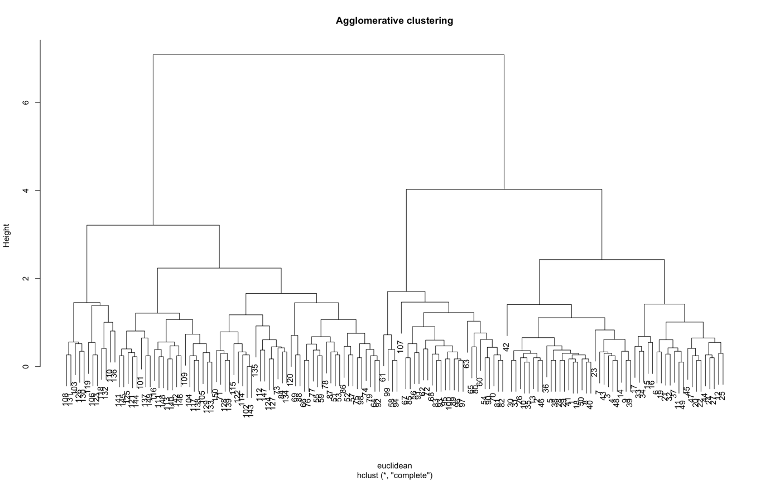

**Code:**

# performing agglomerative clustering with single linkage

agglomerative_cluster = hclust(euclidean, method = "single")

plot(agglomerative_cluster, main = "Agglomerative clustering")

**Output:**

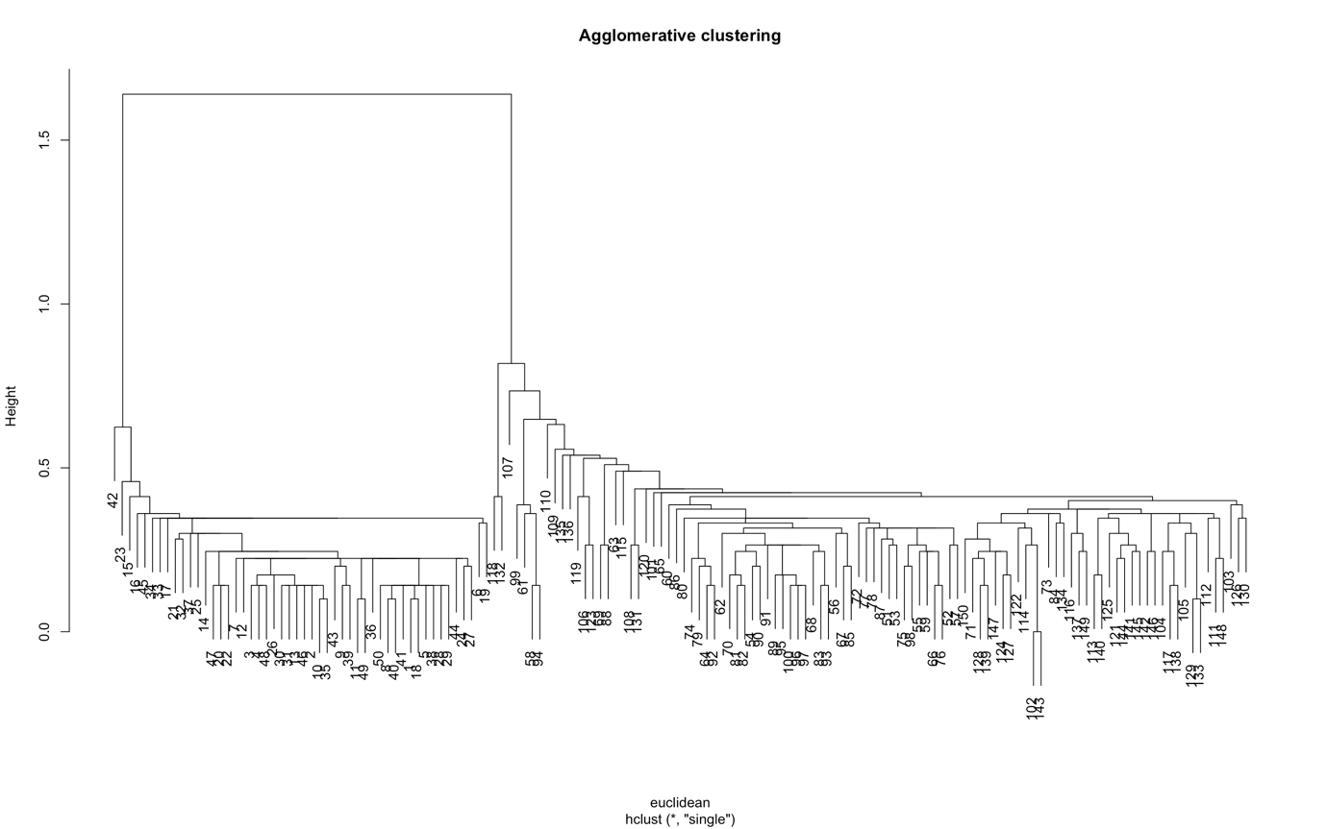

**Code:**

# performing agglomerative clustering with mean linkage

agglomerative_cluster = hclust(euclidean, method = "average")

plot(agglomerative_cluster, main = "Agglomerative clustering")

**Output:**

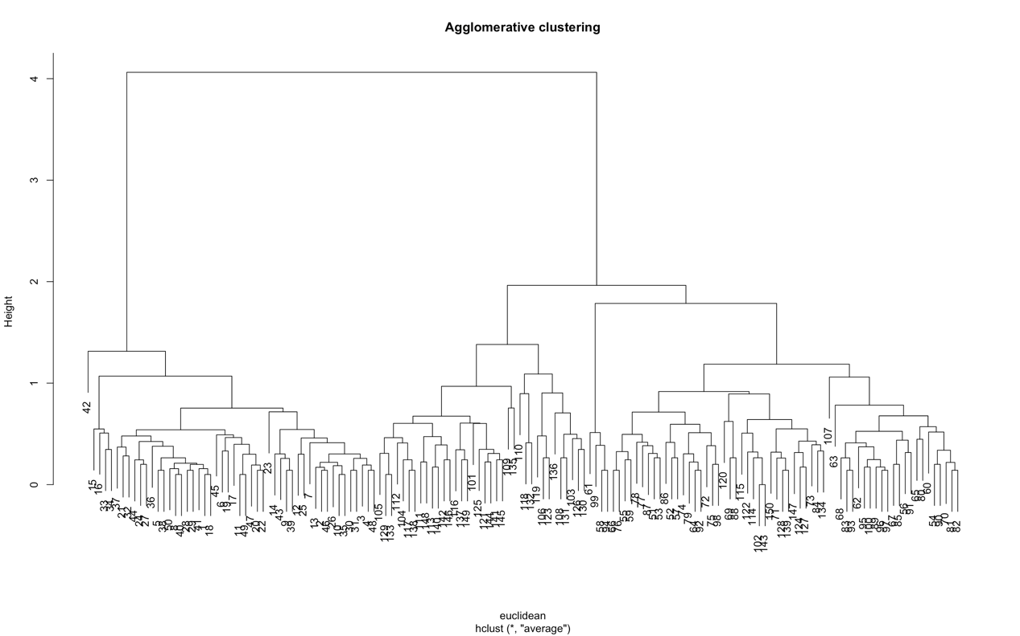

**Code:**

# performing agglomerative clustering with centroid linkage

agglomerative_cluster = hclust(euclidean, method = "centroid")

plot(agglomerative_cluster, main = "Agglomerative clustering")

**Output:**

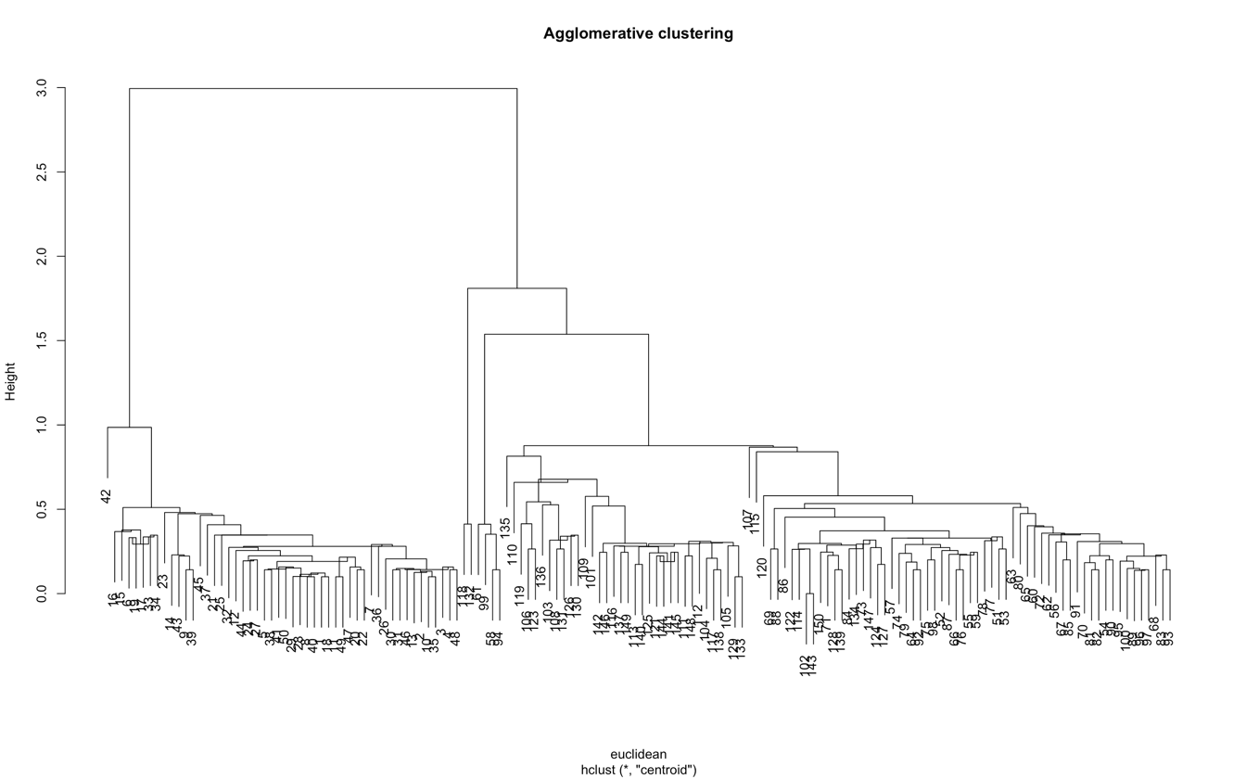

**Code:**

# performing divisive clustering

divisive_cluster <- diana(as.matrix(euclidean), diss = TRUE, keep.diss = TRUE)

plot(divisive_cluster, main = "Divisive clustering")

**Output:**

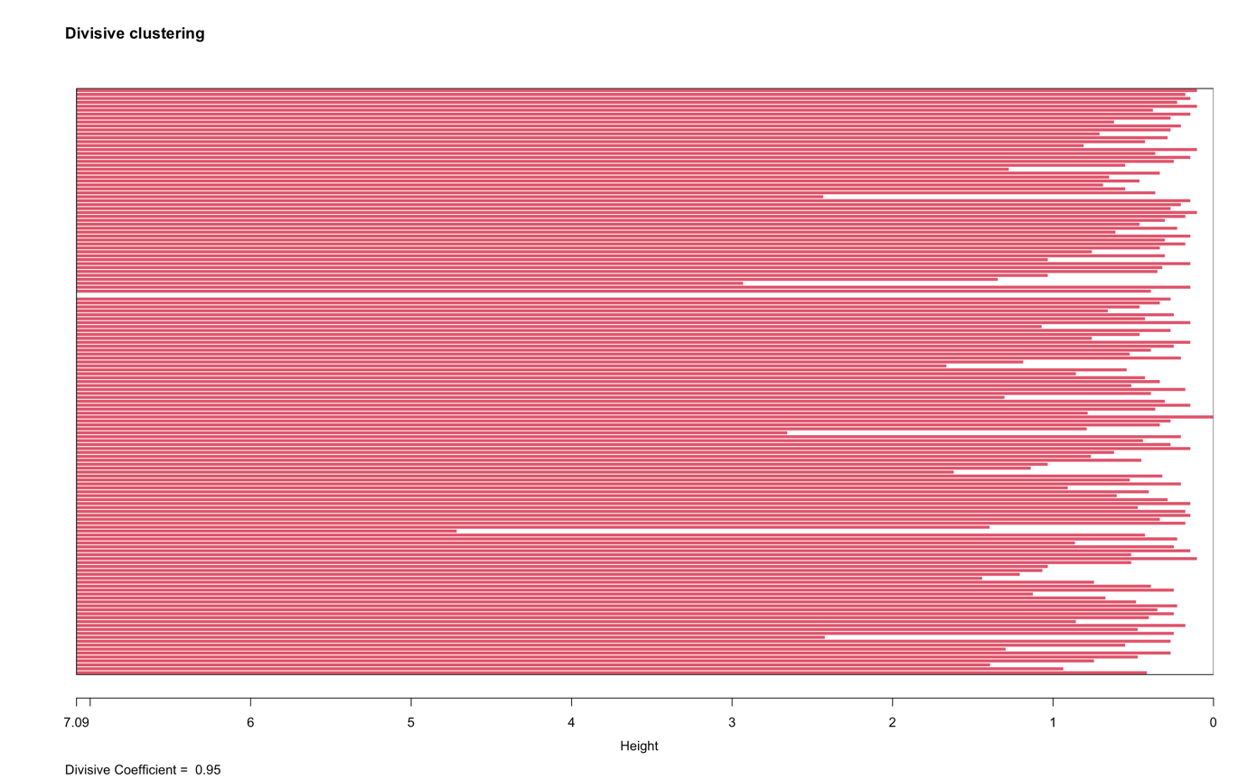

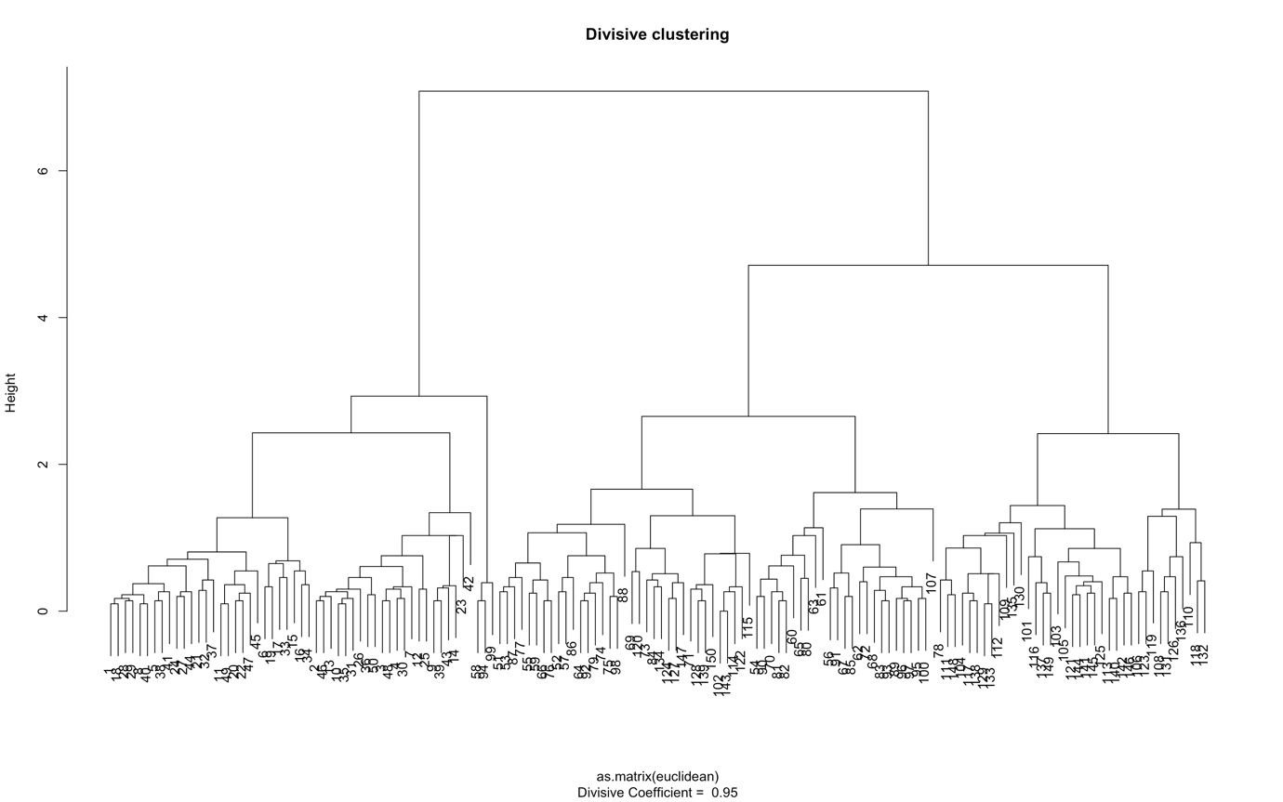

**Code:**

# plotting dividing rectangle

rect.hclust(divisive_cluster, k = 2)

**Output:**

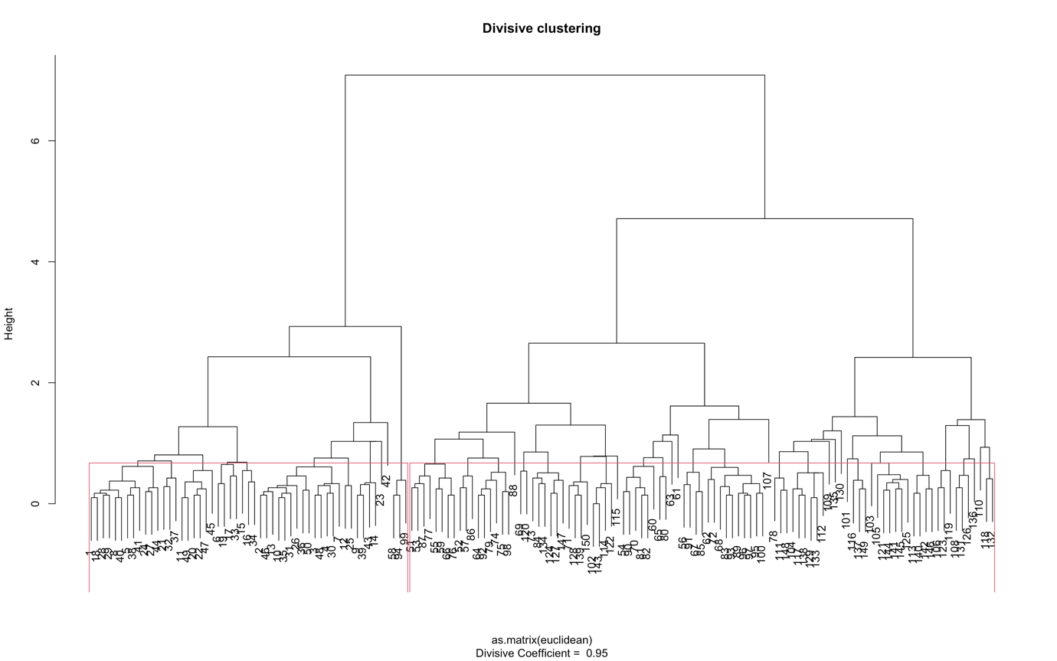

**Code:**

# viewing divided groups

group = cutree(divisive_cluster, k = 2)

table(group)

**Output:**

> # viewing divided groups

> group = cutree(divisive_cluster, k = 2)

> table(group)

group

1 2

53 97